
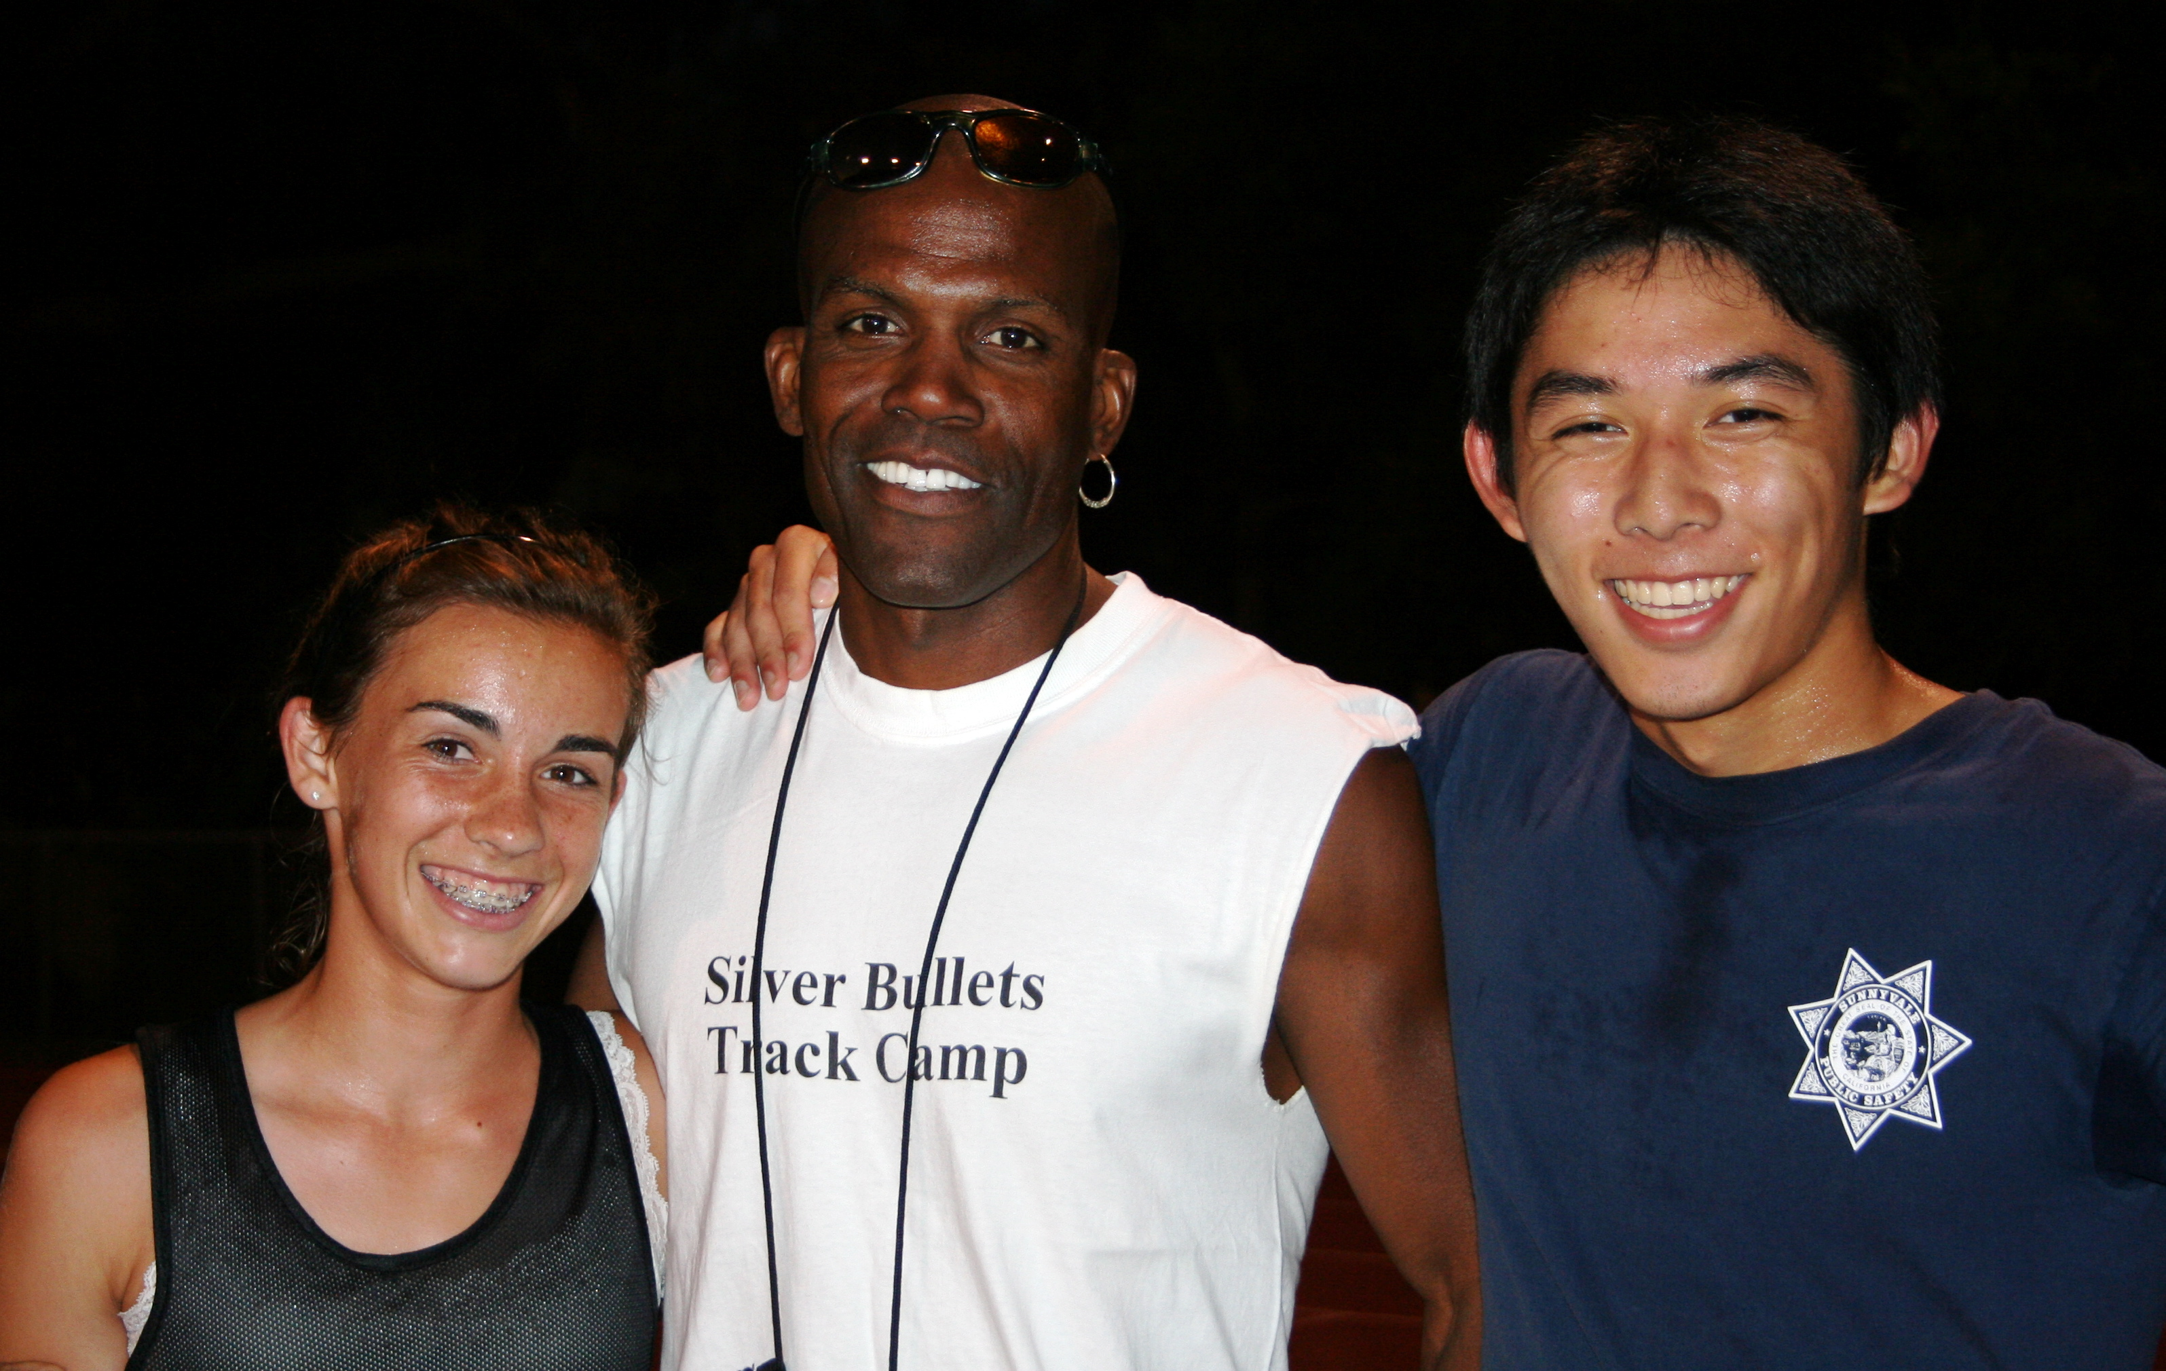


Runners, Take Your Mark…

Join Coach Sealy at the 11th Annual

Silver Bullets Summer Track Camp!

This camp is for all ages from beginning runners to track enthusiasts to competitive athletes to those interested in getting into shape for the summer. Whether you are interested in trying your skills at running or getting into shape for another sport this is the place to be!

- WHO: Kenrick Sealy is the Head Cross Country and Track coach at Homestead High School. As a former collegiate and professional runner, Coach Sealy provides valuable knowledge and experience to his running programs.

- WHAT: Join us twice a week for running workouts that are focused on conditioning and working on your technique. We will also participate in the Thursday evenings Los Gatos All-Comer summer meets.

- WHEN: May 27th - August 5th, 2010
Trainings are Tuesdays & Thursdays from 5:30 - 7:00 pm
Thursday trainings will move to Saturday mornings when the Los Gatos meets begin on June 17th.
- WHERE: Training: De Anza College Track.
Competition: Los Gatos All-Comer Meets @ Los Gatos High School Track.

- COST: Individual $155.00 / Family $255.00

For more information, contact Kenrick Sealy at

408.410.7654 or kenricksealy80@hotmail.com

What are you waiting for? Sign up now!
Application Form
11th Annual
Coach Sealy’s
Silver Bullets Summer Track Camp

Kenrick Sealy
P.O. Box 110271
Campbell, CA 95011-0271
Tel. (408) 410-7654
Email: kenricksealy80@hotmail.com

The following is the official entry form for the 2010 Coach Sealy’s Silver Bullets Summer Track Camp scheduled to begin on May 27th at De Anza College. Please fill out and sign the necessary information that is applicable to you. Make checks payable to Kenrick Sealy.

Name (s): ------------------------------------------------------------------------------------------------------------------

Parents ---------------------------------------------------------------------------------------------------------------------

Address: -------------------------------------------------------------------------------------------------------------------

Email address: ----------------------------------------------------------------------------------------------------------

School/Grade: -----------------------------------------------------------------------------------------------------------

Telephone: (H) ------------------------------------ (cell) ----------------------------------

Fees: Check one Individual $155.00 ( ) or Family $255.00 ( )

I, the undersigned, totally agreed to participate in the aforementioned program with the knowledge that I am capable, fit and healthy to perform the task (s) that is/are asked of me during the length of the camp. I totally understand the terms and agreement of this contract and have all plans on executing them.

Signature -------------------------------------------------------------- Date: -----------------------------------------------

